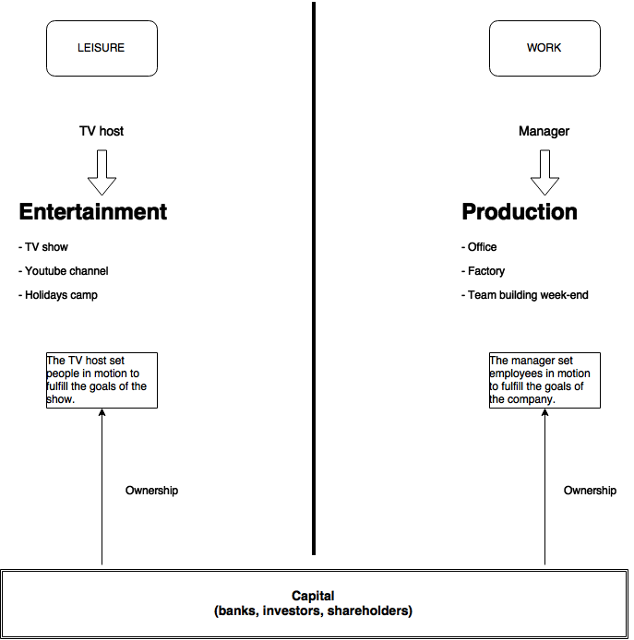

« This is your last chance. After this, there is no turning back. You take the blue pill - the story ends, you wake up in your bed and believe whatever you want to believe. You take the red pill - you stay in Wonderland and I show you how deep the rabbit-hole goes. » – Morpheus, The Matrix

Enjoying the Matrix ???

The Matrix : A definition

The Matrix is everywhere. It is all around us. Even now, in this very room. You can see it when you look out your window or when you turn on your television. You can feel it when you go to work... when you go to the supermarket... when you pay your taxes. It is the world that we let the system pull over our eyes to blind us from the truth.

Yes, I like to quote the movie. But you may have noticed a few differences from the original. Why is that ?

First, I dumped the church and replaced it with the supermarket, because shopping took the place of spirituality in the Western world. Then, this sentence :

« It is the world that we let the system pull over our eyes to blind us from the truth. »

I swear, this is us and no one else. No one is innocent, nobody blindfolded you or me, no one forces us to believe in CNN, CBS or FOX.

You want a definition of the matrix ? The matrix is mainstream, mass media, mass market, mass this, mass that, it's “everybody think that...everybody buys this...”, it's the herd, the think-o-matic behaviour, the mindless crowds pushing against the doors on Black Friday, people doing something because it's in fashion... Do you get the idea ?

The matrix is made of everyone of us every time we play the game by the system's rules: Work, Consume, Rince, Repeat.

Why does it exist ?

The Matrix exist because of us. It didn't fall from the sky or isn't part of a plan from some evil entity to steal the world. It is simply a byproduct of the Industrial Way of Life: Mass production and mass entertainment gave birth to an epidemic of herd mentality. Human beings are social creatures. We are naked monkeys depending on each other to survive. The better integrated to the tribe we are, bigger our chances of survival.

In rough times, when you actually have to hunt for your food (or be hunted by your food), this behavior makes sense. But in our current society, it's a curse. We can be individuals, we can think by ourselves, we can express our own opinions without fear of reject, because being rejected doesn't mean probable death anymore.

Annoyingly, industrial-scale organizations (governments, medias, corporations) quickly learned how to take advantage of the herd-like nature of the masses. Books have been written that tells this truth. In the 1920s. Have a look at “Propaganda” by Edward L. Bernays, it’s shocking.

Damn, this text is almost 100 years late.

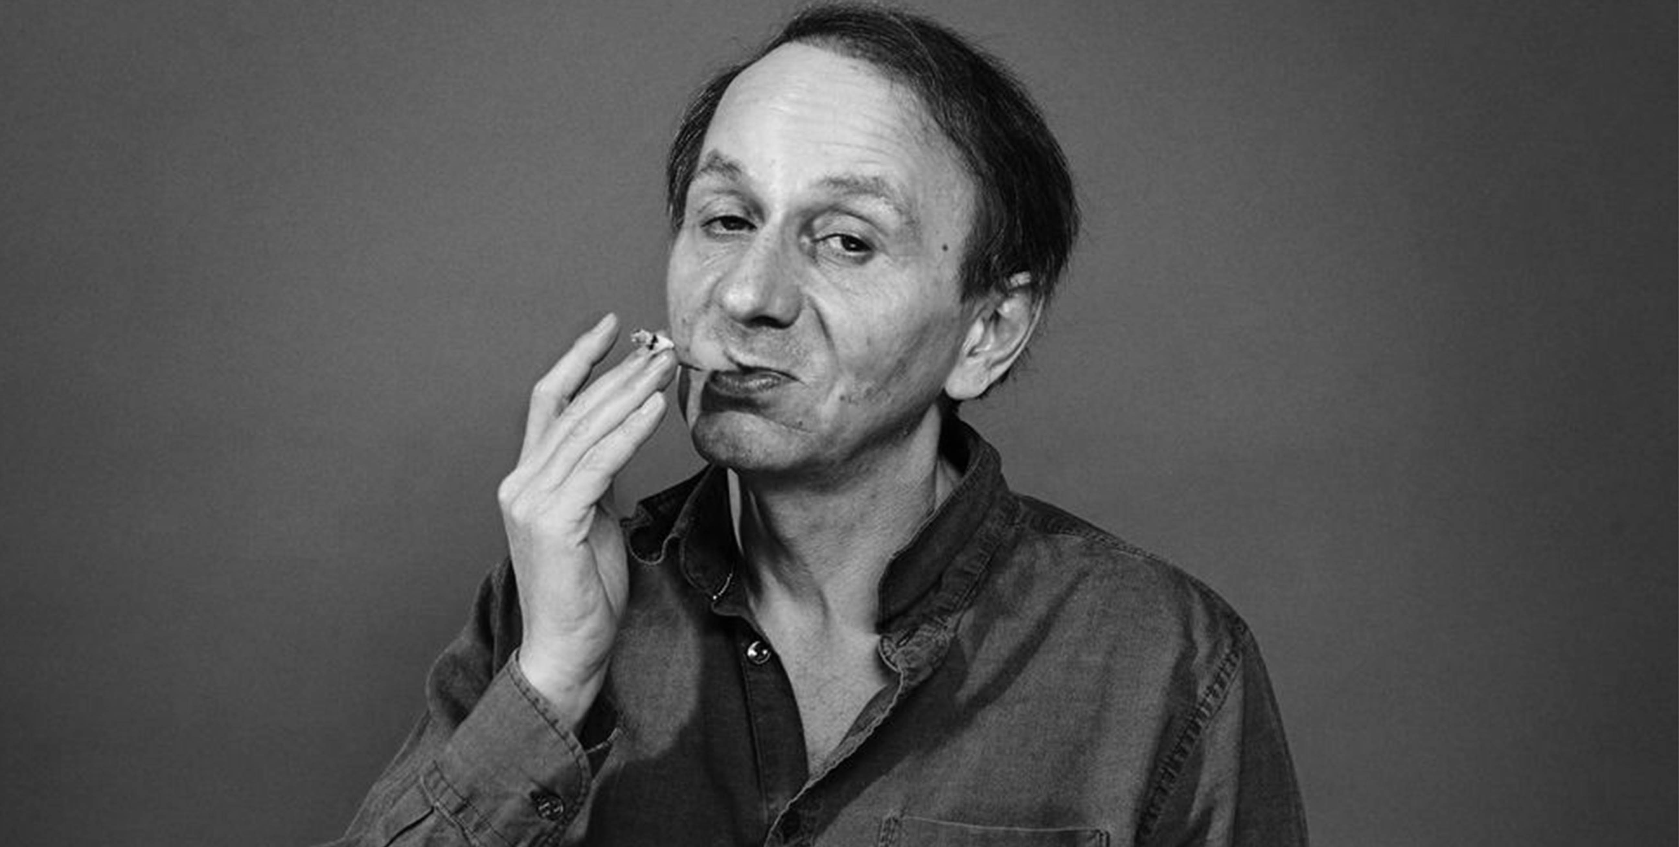

Michel Houellebecq
French author, filmmaker, and poet.

"Active people don't change the world profoundly, ideas do. Napoleon is less important to world history than Rousseau."

Life in the Matrix

As said previously, the Matrix is a consequence of the industrial nature of our world and the Industry always target masses. Why is that ? Because launching products cost a lot of money, money that comes from the pockets of private or public investors: rich individuals, banks, governments, business angels…

The only way for these people to get some return on their investment is to make sure whatever they are funding will meet the needs of a large number of customers: “To make millions, target millions”.

Ask Karl Marx, he will tell you there are three Classes: the Rich (1% of the population; you never see them, their world is light-years away from ours), the Aspirational 14% (they wish they were rich; they are to some extent) and the Proletariat (85%, also known as the Working Joes).

The universe of the Proletariat (also called Consumtariat or Entertaintariat) is made of:

- Food: chain restaurants, supermarkets, bulk buys, processed goods, GMO fruits and vegs, industrial-grade meats (antibiotics included)
- Housing: overpriced copy/paste flats or houses in the suburbs, mass-produced vehicules, location chosen in respect to affordability
- Culture: blockbusters, tittytainment/infotainment, sci-fi/romance novels, Top 10, best sellers
- Politics: believe in the Right/Left Democrats/Republicans division
- Money: in debt for everything (house, car, phone, computer, TV…)

The key characteristic of the Proletariat / Consumtariat / Entertaintariat is that the members of this social class live in a world designed by others, with the masses in mind. The fact that you have to find the smallest common denominator when you want to please a huge number of individuals explains why our everyday life is filled with uninspired unassuming crap.

Reasons not to cooperate

Let's be clear about something, something disturbing: the Matrix is comfortable. It's warm. There's room for legs. There's plenty of nice food, nice people, the air conditioning works perfectly.

If you're obedient enough for long enough, you can have a nice house, a nice car, successful kids and even holidays. What a good deal !

Really, many people seems to do well in there. Comfort, money, a decent level of wealth in general, education, colored yum yums, plenty of toys, smartphones, tablets, flat screens the size of a football field...what kind of idiot wouldn't jump into that train ?

But.

You read this text so far. Maybe because of the title. Maybe because of the cover. Maybe because of the itch.

You tried your hardest to get rid of it : music, movies, hobbies, credits, holidays, work, love, hate, politics, literature... At best, you muffled it for a while. Then, it came back: anger, sadness, depression... And now, this text.

You have the intuition that something is amiss. You feel that you're missing something. Like a dead pixel in a digital photo, like an out-of-tune note in a symphony, like a speckle of dust on the lens (I could go on for hours), something is not where it should be.

Well, you know how your body rebuilds itself using the food you eat, right ? Your guts disassemble everything you put in your mouth and uses it as construction material. You become what you eat.

It's the same for your soul. You become what you do; as the French philosopher Michel Clouscard put it in La Bête Sauvage (The Wild Beast), your culture is your soul. It might seem strange, but I came to realize this is very true.

If you never open a book (most fictions, novels and love stories doesn't count), if you just listen / read / watch whatever is advertised by mainstream media, then your soul is made of this crap. Don't think I’m being pedantic, I’m not judging you any way.

Deep inside, you know I'm not lying.

Your culture, your soul

Over the years, I found that we spend most of our time recombining existing elements: ideas, pictures, quotes, music, paint... Real creation doesn't happen often. Our minds, our imaginations feed off the things we see, the texts we read, the music we listen to... Our cultural environment sets our standards in life, for everything we do: food, music, taste in general, the way we talk, the clothes we buy,...

Often, we hear people say : “I don't get why students have to learn arts, music, geography or history. It doesn't help to pay the bills.”

It's not about the bills, it's not about your stomach at all. It's about the fabric of your deep self, your soul. Climb the cultural ladder, buy this ticket to better taste, get a glimpse at something else than MTV, gangsta rap, bitches and evil muslims.

The road to a better life crosses the path to a better self.



Jean Baudrillard (1929 – 2007)
French sociologist, philosopher, cultural theorist, political commentator, and photographer.

"It is always the same: once you are liberated, you are forced to ask who you are."

The outside world

Not a pleasant place if you want my opinion. Who lives there ? Well, mainly people who are too dumb or too mad (or both) to be accepted in the matrix. This is the sad truth about the outside world. Nevertheless, some of its inhabitants are wonderful and exiting: creative geniuses, authentic artists, passionate scientists, culture lovers, talented musicians, visionary graphic designers, all knowledgeable, clever and open minded fellows.

Good. You're probably like me though, an honest, but somewhat limited human being. Not good at drawing, can't sing, couldn't write a good novel, bad at math, certainly not a genius... Does it mean we belong to the too-dumb-too-mad category ?!

Hopefully, no. Living outside the matrix doesn't require anything special. You don't need to make big changes to your life: do the switch step by step. Believe me or not, I started by climbing the stairs instead of using the elevator. It was that simple. This effort was quickly followed by another one: instead of listening to music while commuting, I decided to read books written by philosophers, sociologists and politicians. Also, I lost a few kilos (sadly, they came back later, shame shame shame !).

Reading books doesn't make you more intelligent right on the spot. Books gives you tools to understand the world around you. The good news is you don't have to read a lot, but to read what matters. Pick books that you think will make a difference.

Some inspiration: THX 1138

"Let us be thankful we have commerce. Buy more. Buy more now. Buy. And be happy.", THX 1138, by George Lucas, 1971.

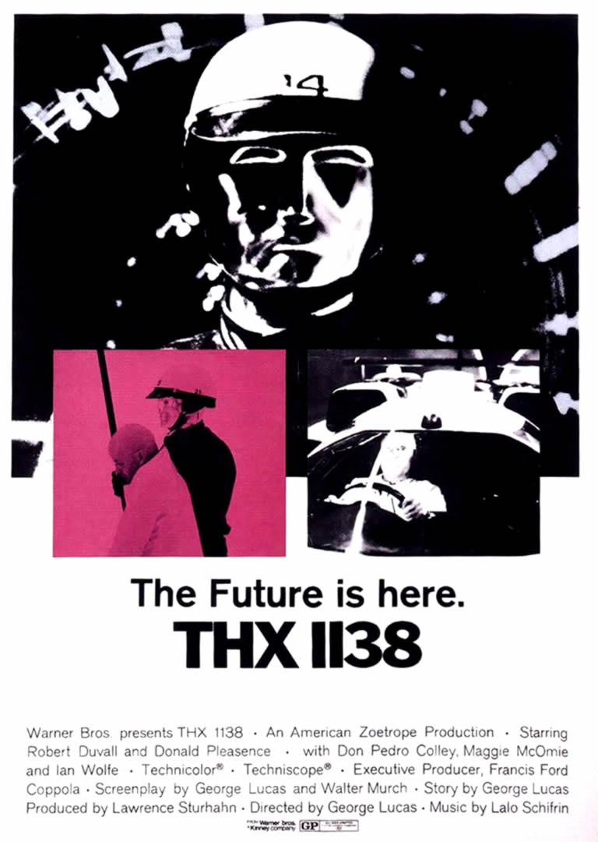

Yes, the George Lucas who created Star Wars. It took me by surprise too.

Let's be clear about something: leaving the matrix is not a big deal, I mean, you don't have to set anything on fire or to speak angry words at anyone. To the others, you will remain unchanged for quite a while. One day they will notice, they will see the way you make your decisions has changed, the things you like are different, but not immediately.

And that's perfectly fine. You don't have to become or to behave like a weirdo just because you chose to read Arthur Schopenhauer instead of Dan Brown. Hipsters are a bad example: they look weird and they are known to despise anything they consider mainstream. Avoid idiots, but don't become an arrogant fool. Instead, share your passion and your new discoveries with anyone who might be interested.

Run Logan !

I'm pretty sure that many of you, readers, don't really believe me. Leaving the comfort of the matrix ? What for ? I don't want to become socially awkward ! I don't want to disconnect from what my friends like ! I don't want to become a stranger in my own family !

First, getting interested in alternative culture doesn't mean you will become some kind of creepy Cthulhu cultist. What will happen to you is just that: you will enhance your taste, improve your culture, get a better understanding at the way the world works, refine your opinions, discover new ways of thinking, overall, you will become more knowledgeable. People like that, because this planet is full of blind fools.

Second, you will discover that some books can move you much more than any movie. Some texts will literally touch your soul, you will feel like if the author wrote it especially for you. It's an exhilarating sensation, because someone else felt exactly the way you feel and put it on paper. Such an experience will change your understanding of the words “soul mate”.

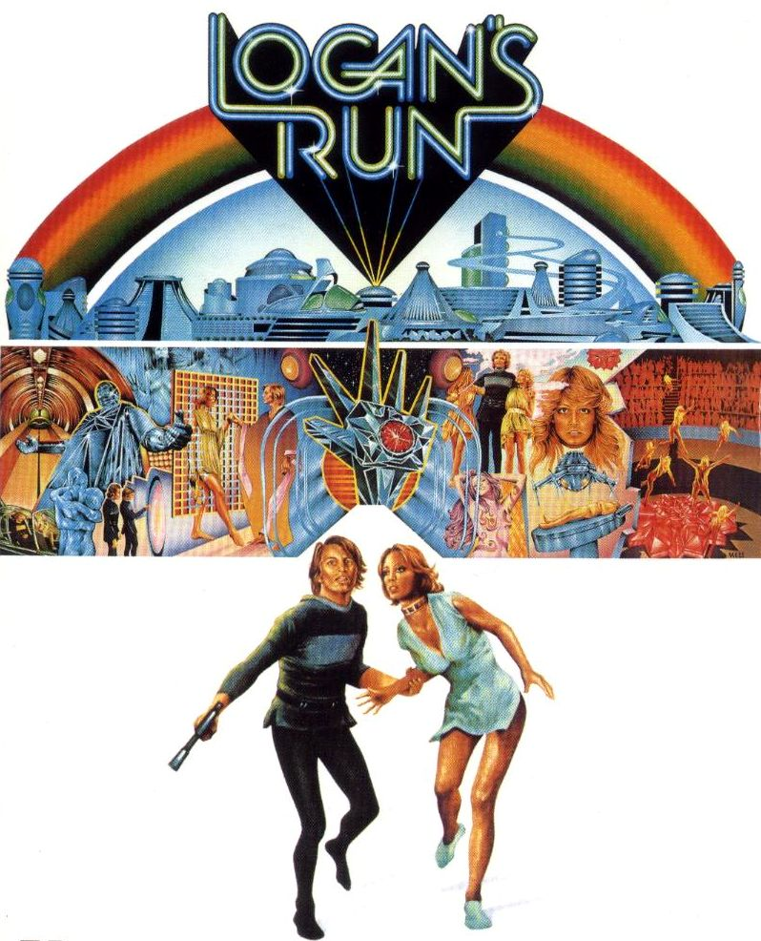

Change

Oh well, last paragraph. Already. Have I said what I intended to ? Not sure. I hope you will be kind and pardon me if I ever forgot something. It's not easy not to sound like some inspirational chakra-opening guru.

My message is: when asked to choose between A and B, ask about C, D...up to Z. Listen to classical music, jazz music, death metal, doom metal, even this disgusting crap called world music. Read books written by sociologists, philosophers, read good science-fiction (Dan Simmons for example).

Play seemingly obscure video games created by small studios, watch movies in their original language, quit the Right/Left loop-of-death when it comes to politics, try to be a vegetarian for three months, do some sport, stop buying stuff made by kids and farewell.

Don't limit your choices to whatever the mainstream media have on their menu.

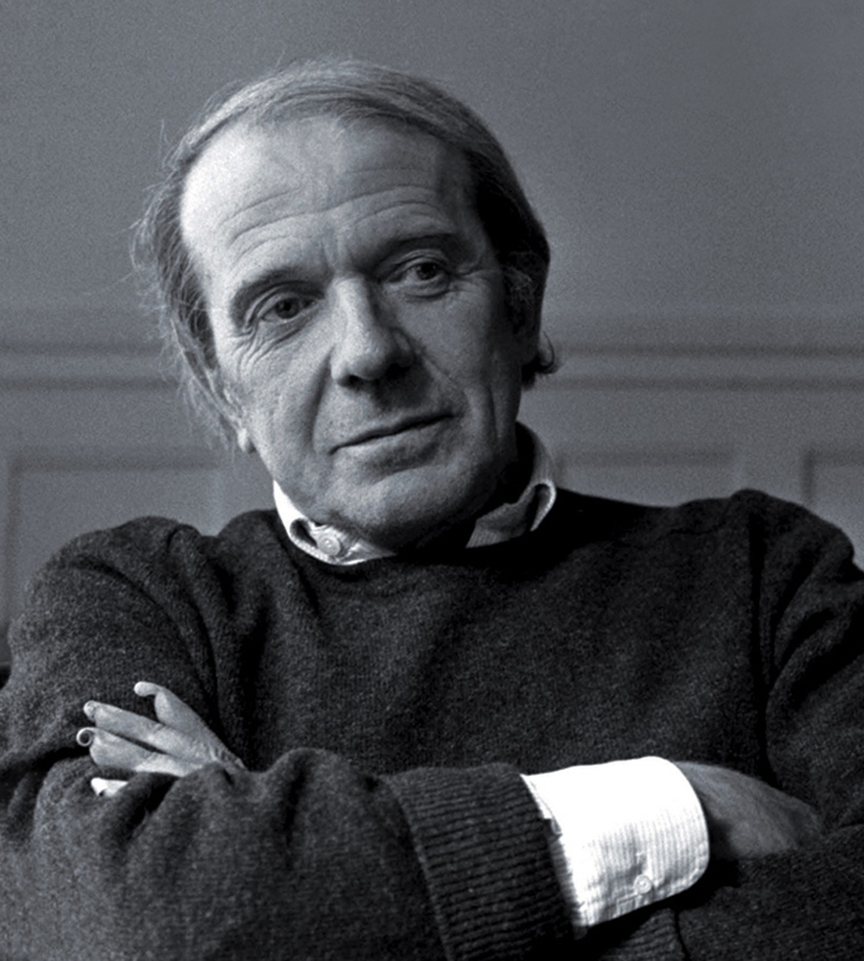

Gilles Deleuze (1925 – 1995)
French philosopher.

"There's no need to fear or hope, but only to look for new weapons."

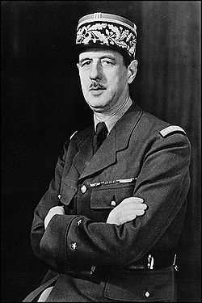

Charles André Joseph Marie de Gaulle (22 November 1890 – 9 November 1970)
French general, resistant, writer and statesman.

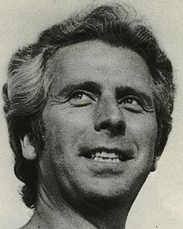

Michel Clouscard (August 6, 1928 – February 21, 2009).
French Marxist philosopher and sociologist.
Professor of sociology at the University of Poitiers from 1975 to 1990.

